<!doctype html>

<html>

<head>

<link rel="stylesheet" href="nav.css">

<title>

AVENUE:hotel management system

</title>

</head>

<body oncontextmenu="return false;">

<script>

window.onload = function() {

document.addEventListener("contextmenu", function(e){

e.preventDefault();

}, false);

document.addEventListener("keydown", function(e) {

//document.onkeydown = function(e) {

// "I" key

if (e.ctrlKey && e.shiftKey && e.keyCode == 73) {

disabledEvent(e);

}

// "J" key

if (e.ctrlKey && e.shiftKey && e.keyCode == 74) {

disabledEvent(e);

}

// "S" key + macOS

if (e.keyCode == 83 && (navigator.platform.match("Mac") ? e.metaKey : e.ctrlKey)) {

disabledEvent(e);

}

// "U" key

if (e.ctrlKey && e.keyCode == 85) {

disabledEvent(e);

}

// "F12" key

if (event.keyCode == 123) {

disabledEvent(e);

}

}, false);

function disabledEvent(e){

if (e.stopPropagation){

e.stopPropagation();

} else if (window.event){

window.event.cancelBubble = true;

}

e.preventDefault();

return false;

}

};

</script>

<p class="red">

<img src="main.jpg" alt="">

<span>AVENUE : HOTEL MANAGEMENT SYSTEM <br>DIRECTOR:- RAHUL BAGAL

<br>FOUNDER:- SAURABH PATIL

</p>

<br>

<br>

<br>

<br>

<br>

<br>

<br>

<br>

<br>

<br>

<br>

<br>

<br>

<br>

<ul>

<b>

<li><a><a href="#" onclick="AV()">HOME</a>

<ul>

<li><a href="manager.html">MANGEMENT CELL</A></LI>

</UL>

</li>

<li><a><a href="reception.html">RECEPTION</a>

<ul>

<li><a href="reception.html" onclick="abc()">GUEST & SERVICES</A></LI>

</UL>

</li>

<li><a>BOOKINGS</a></a>

<ul>

<li><a><a href="booking.html">BOOK NOW</a></a></li>

<li><a><a href="trans.html">TRANSPORTATION</a></a></li>

<li><a><a href="guestroom.html">GUEST ROOMS</a></li>

<li><a><a href="pool.html">POOL</a></a></li>

<li><a><a href="TRY.html">GAME SLOTS</a></a></li>

<li><a><a href="partyhal.html">PARTY HALL</a></a></li>

<li><a><a href="wedding hall.html">WEDDING HALL</a></a></li>

<li><a><a href="meetinghall.html">MEETING HALL</a></a></li>

</ul></li>

<li><a>GALLERY</a>

<UL>

<li><a><a href="gallery.html">OVERVIEW</a></a></li>

<li><a><a href="VISIT.html">CELEBS VISIT</a></li>

</UL>

</li>

<li><a href="#">LOGIN</a></a>

<UL>

<li><a><a href="login.html">GUEST LOGIN</a></a></li>

<li><a><a href="login1.html">STAFF LOGIN</a></li>

</UL>

</li>

<li><a><a href="contact.html">CONTACT US</a></a></li>

<li><a><a href="about.html">ABOUT</a></a>

</b>

</ul>

<br>

<br>

<div class="alpha">

<img src="bed2.jpg" id="e">

<div class="alpha-m">

<p1>OFFER<br><del>Rs.5999</del><br>Just <ins>Rs.3999</ins></p1>

</div>

<div class="beta">

<img src="login.jpg" id="f">

<div class="beta-n">

<p2>POOLs<br>and <br>RESORT </p2>

</div>

<div class="game">

<img src="game.jpg" id="x">

<div class="game-g">

<p3>SPACIOUS<br>indoor<br>GAMing</p3>

</div>

<img src="1g.gif" id="f1">

<img src="2g.gif" id="b1">

</p>

<SCRIPT>

function AV()

{

alert(" :-) YOU ARE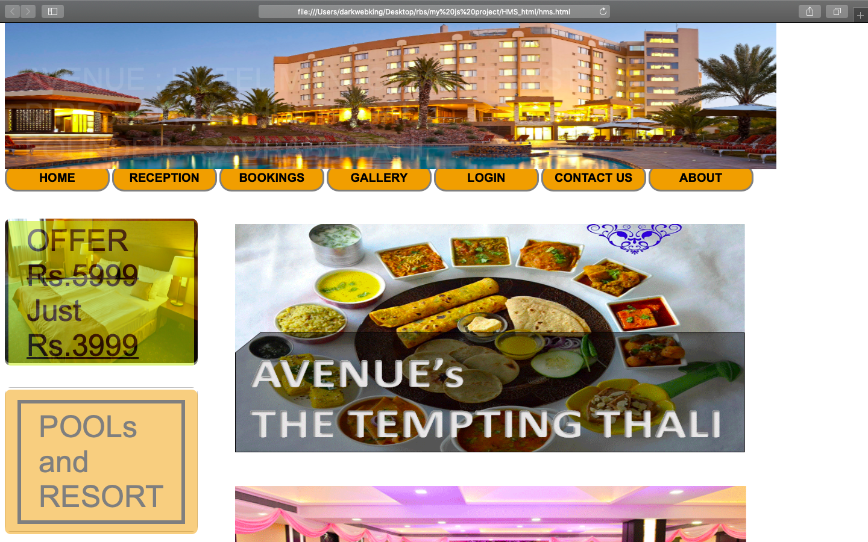 ON HOME PAGE :-)");

}

function abc()

{

var a = prompt("enter guest ID")

if(a=="")

{

alert("please enter guest ID");

}

else

if(a=="ABCD")

window.open("guest.html");

else

alert("invalid guest id");

}

</SCRIPT>

</body>

</html>

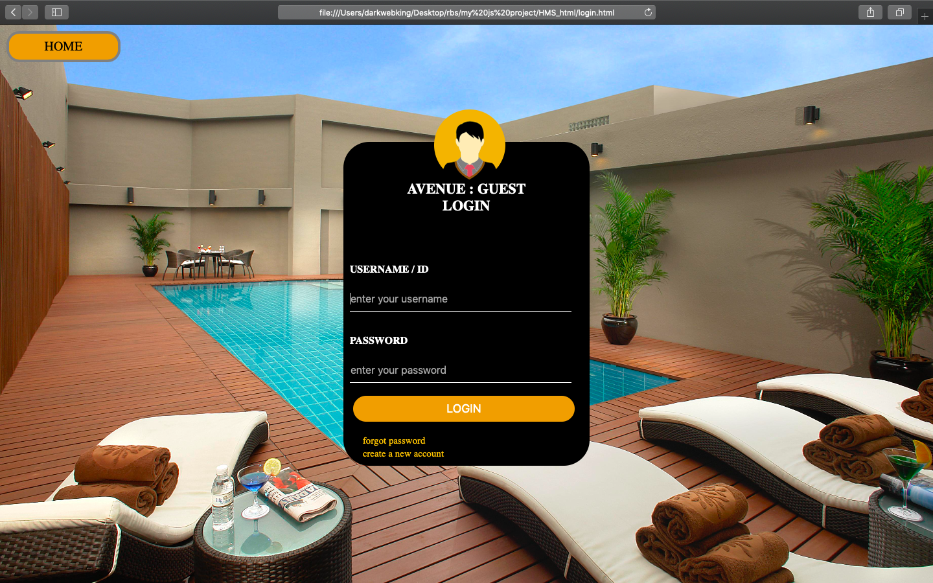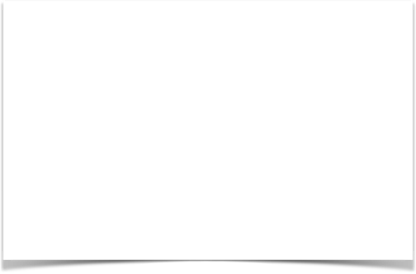

|  |  |  |  |  |  |  |
| --- | --- | --- | --- | --- | --- | --- |
| **Sr No.** | **Test Case ID** | **Input Data** | **Expexted Result** | **Actual Result** | **Status** |  |
| 1 | C1 | Click on Login | Go to Login Page | Login page is opened | Pass |  |
|  |
| 2 | C2 | Click on Create Account | Go to Sign in page | Sign in page is displayed | Pass |  |
|  |
| 3 | C3 | Products List | Go to Products page | Page is displayed | Pass |  |
|  |
| 4 | C4 | Login Page | Valid username, password | Validation successful | Pass |  |
|  |
| 5 | C5 | Sign in page | Valid information required | Validation successful | Pass |  |
|  |
| 6 | C6 | Sign in page | No blanks left | Validation successful | Pass |  |
|  |
| 7 | C7 | Login Page | No blanks left | Validation successful | Pass |  |
|  |
| 8 | C8 | Contact | Go to contact information | Contact page displayed | Pass |  |
|  |
| 9 | C9 | Feedback | Opens feedback page | Page is displayed | Pass |  |
|  |
| 10 | C10 | Login Button | Validates if information is correct | Validation successful | Pass |  |
|  |
| 11 | C11 | Forgot Password | Opens password changing page | Page is displayed | Pass |  |
|  |